Brookfield High School Grad Party 2023

Celebrate your Graduate’s success by purchasing a lawn sign to proudly display his/her achievement on your front lawn!
The sign is yellow with blue lettering and will appear similar to the following:
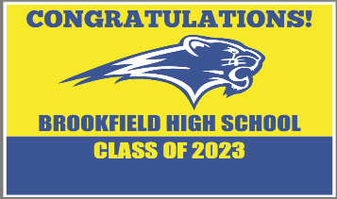

Cost: $20.00 without personalization ~ $25.00 with personalization(first name only)
Order and payment is due by Friday, May 26, 2023.
You will be notified once your sign is ready for pick up.

2 Ways to Pay: By Venmo (@BHS-CT-GradParty) but you must include all of the info below or mail this form and check payable to “BHS CT Grad Party” to:

BHS CT Grad Party
PO Box 74
Brookfield, CT 06804
Attn: Grad Party 2023: Christine Goodsell, Treasurer

Parent/guardian Name:__________________________________________________

Email:_________________________________________________

Phone #:__________________________________________________
Senior’s name:_______________________________________________
Number of Signs: ____ x $20.00 per sign = $___________
Personalization: ____ x $5.00 per sign = $___________
Total = $______________
Name on Sign (first name only)_______________________________

Proceeds from this sale will help fund the substance-free BHS Grad Party 2023
Questions? Contact Marlene McGrade: msmcgrade@charter.net

