January 21, 2026

Dear Parents,

Brookfield High School Grad Party is celebrating its 40th Anniversary this year! Planning is underway, but the party is at financial risk for the future. We are counting on our school community to come together to keep this tradition going.

We’ve changed things up a little this year and are offering the chance to participate in ONE fundraiser that will help fund the event this year/future and the 250 raffle prizes. We want every graduate to go home happy!

CLICK HERE: 2026 Grad Party Fundr Link
4 Levels to Choose From + an Other Value Option

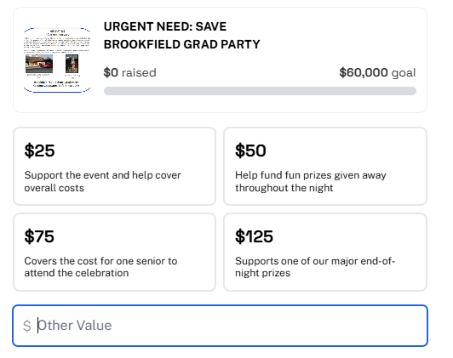

If you are not familiar with Grad Party, it is an overnight celebration for BHS seniors on graduation night. Parents and community volunteers transform the school around a theme, and graduates spend the night playing games, winning prizes, and celebrating together one last time. This event requires significant planning and funding and is supported entirely by donations from parents, local businesses, and community organizations.

Your support truly makes a difference and helps us provide a safe, fun, and memorable night for our graduates. This is the year that will help continue the tradition in the future.

Best Regards,

BHS Grad Party 2026, Fundraising Committee

BHS CT Grad Party
PO Box 74
Brookfield, CT 06804

fundbhsgradparty@gmail.com

